Lab 01: Installing a Virtual Machine and Linux (CentOS)

Objectives
- Understand the process of installing and configuring a virtual machine using VirtualBox.
- Learn to download and install CentOS Stream as a guest operating system on the VM.
- Familiarize yourself with basic CentOS setup tasks, including:
  - Configuring network settings.
  - Setting up user accounts and root passwords.
  - Selecting software packages during installation.
- Explore the CentOS Stream desktop environment and its core utilities.
- Execute basic Linux commands (pwd, ls, whoami, date) in the terminal to verify installation success.

Mapping
Chapter 1 in the textbook.

Requirements
- Hardware/Software Requirements:
  - A computer with internet access.
  - At least 8 GB of RAM and 40 GB of free storage space.
  - VirtualBox or VMware software installed.
  - CentOS Stream installation ISO downloaded from centos.org.
- Pre-requisites:
  - Ensure VirtualBox or VMware is installed on your computer.
  - Verify the CentOS ISO file matches your system architecture (x86_64 or ARM64).
  - Familiarity with basic computer operations, including downloading files and navigating through GUIs.
Deliverables
- Submission Requirements:
  - Capture key steps as outlined below:
    - Part 1. (Installing VirtualBox or VMware):
      - Submit only the final confirmation screen showing successful installation of VirtualBox or VMware.
    - Part 1. (Creating a Virtual Machine):
      - Submit a screenshot of the Virtual Machine Summary showing the created VM with its name, type (Linux), and settings.
    - Part 2. (Initial CentOS Setup):
      - Submit a screenshot of the desktop environment after logging in to the CentOS VM.
    - Part 3. (Verifying Installation with Commands):
      - Submit a screenshot of the terminal showing:
        - The username (student code, e.g., HE111111).
        - The hostname (subject code, e.g., OSG203).
        - Results of the pwd, whoami, date, and ls commands.

  - All screenshots must:
    - Be in full-screen mode, clearly showing the entire desktop, including the VirtualBox/VMware window and CentOS interface.
    - Display the username logged into CentOS as the student code. For example:
      - Username format: HE111111 (replace with your assigned student code).
    - Display the host name set as the subject code. For example:
      - Host name: OSG203.
- Console Requirements:
  - The CentOS terminal prompt should reflect the format:
    - HE111111@OSG203.
  - This format will be used as the key for authority verification of the student's work.
- Submission Format:
  - Compile all screenshots into a single PDF or Word document with clear captions describing each step.
  - Ensure the file is named as <StudentCode>_Lab1_Submission (e.g., HE111111_Lab1_Submission.pdf).

Practice Contents

- Download the virtual machine client software.
- Go to https://www.oracle.com/virtualization/technologies/vm/downloads/virtualbox-downloads.html (or for VMWare https://store-us.vmware.com/) and download the installation program. Run the installation program. Perform the following steps.

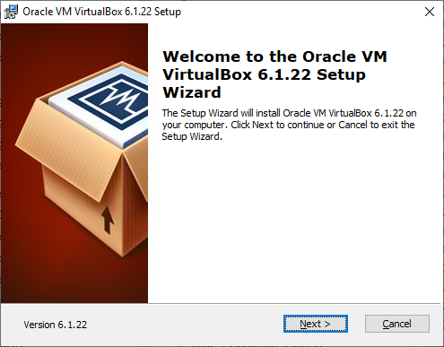

- Select Next on the Wizard Setup and on the Custom Setup windows.
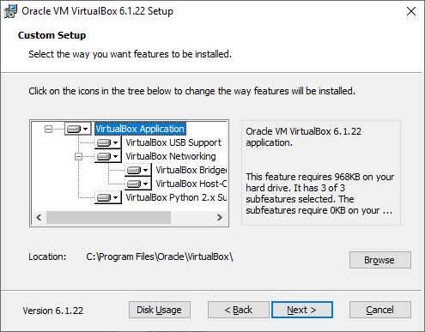

- Select which features you want from the window shown below and click on Next. The window afterward warns you of a possible loss of network during installation. Click Next. At the Ready to Install window, click Install. As installation proceeds, you are given an update bar as shown below.

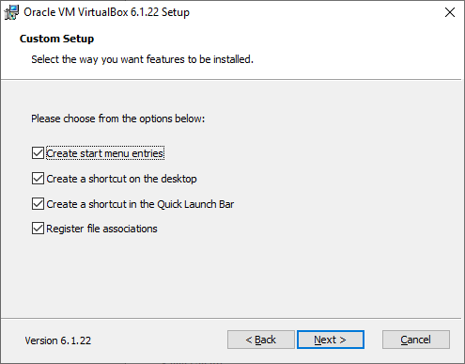

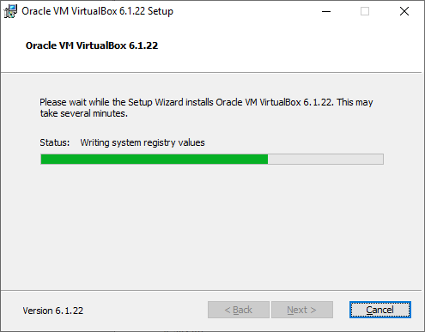

- Upon completion, select Finish. The window has a checkbox for starting VirtualBox. If you are ready to proceed, make sure it is checked.
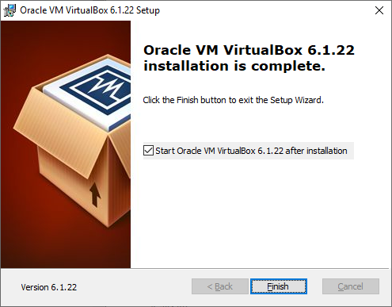

- Installing VirtualBox (VB)
- If VB did not start upon finishing, start it. Upon running VB, you get the interface shown below. Currently the only choice we are interested in is New to create a new VM. Before you do so, make sure you have downloaded the CentOS Stream installation image. Go to https://www.centos.org/download/ and select among the CentOS Stream options. Installation programs exist for x86_64, ARM64, IBM Power, and in versions 8 and 9. Select the ISO that matches your architecture. Make a note of where you have stored the ISO as you will need it in the following steps.

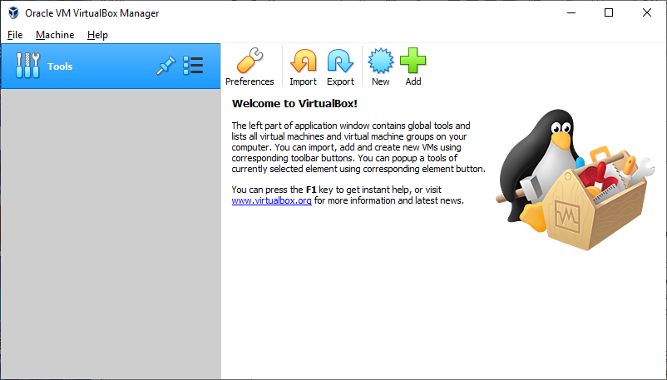

- After selecting New, you are presented with a new window start your VM creation. At the bottom, select Expert Mode. This changes the window to the one shown below. Name your VM. The entry under Machine Folder will be the location where VB will store the VM image. You can change this if desired. Select Linux and Red Hat (64-bit) for Type and Version. Adjust the memory size if desired. Select “Skip Unattended Installation”.
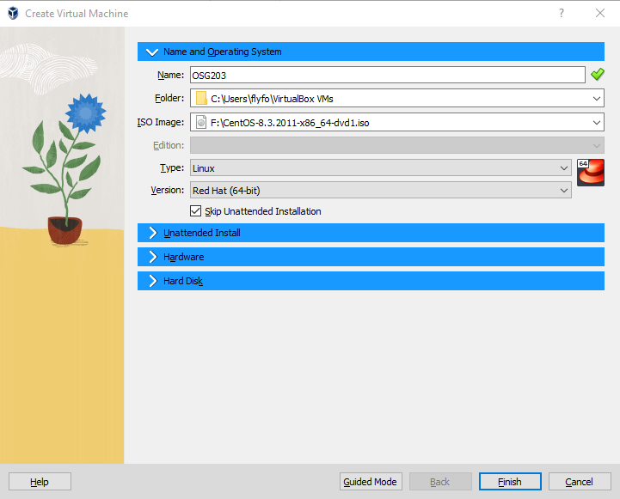

- On Hard Disk tab, you are now presented with a Create Virtual Hard Disk window. Adjust the file size to be larger than 8GB. 32 to 40GB are recommended. Note that this is the physical size that the VM will take up on your hard disk. If you are tight on room, you might want to store the VM elsewhere like an external hard disk or a sizeable USB flash drive but then you will need to remember to plug in the storage device before using your VM. It may also slow down access to the VM. Leave the other options as the default and select Create.
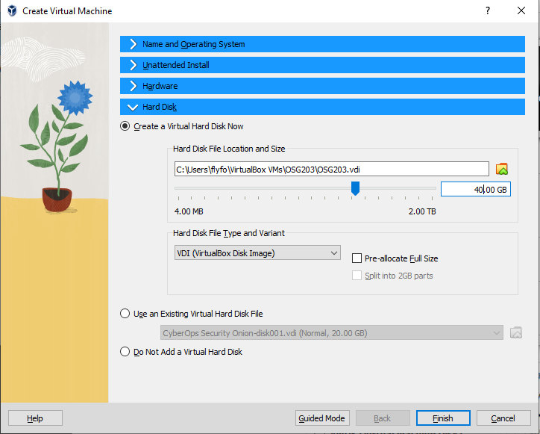

- Creating a VM
- Now, the VM is created and you see it listed in the main VB window. Select it (if it is not already selected) and click on the Start button.

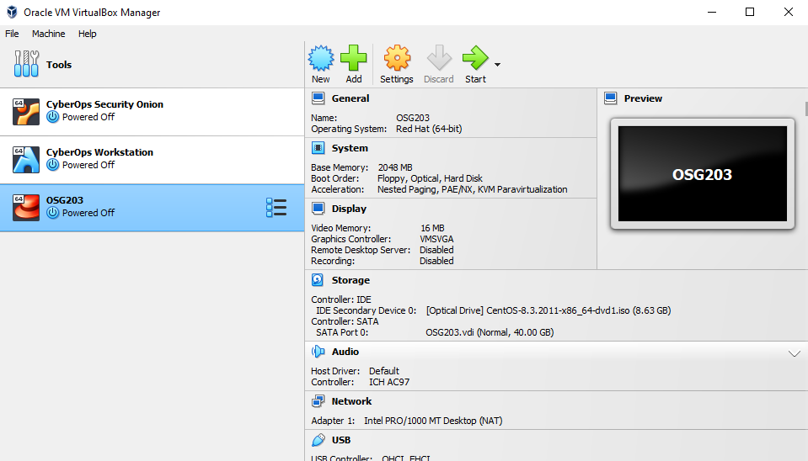

- At this point, VB needs to know the image of the installation program. It asks via a Select start-up disk window. Select the folder icon and from the pop-up window, locate the iso file. Once selected, it will appear in the box near the bottom of the window. Select Start to begin the installation process.
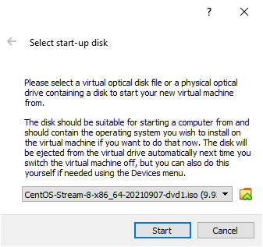

- Installing CentOS Stream
- Installing the OS
- When installing CentOS, the first screen provides us with three options: install CentOS, test the media, and troubleshoot. Testing the media is only necessary if we have saved the iso on an optical disc and want to test it before installation. Troubleshooting is used when either our installation has failed or we want to update the OS version. By default, testing the media is likely chosen. Select the Install option and press <enter>. Note: for your input devices (mouse, keyboard) to operate the VM, you need to click your mouse somewhere within the VM. At that point, both mouse and keyboard control the VM, not your outer computer. To resume access to the outer computer, press the right <ctrl> button. Moving to the outer computer differs in VMWare (where it is usually pressing <ctrl>+<alt> together). Remember that every time you leave the VM for your outer computer, you will have to click in the VM to again regain control of the VM and press the right <ctrl> key to resume access to your outer computer.

- The next screen asks you to select your language, and the specific version of the language, of choice. By default, English and English (United States) will be chosen. Change these if desired and select the Continue button near the bottom of the screen.
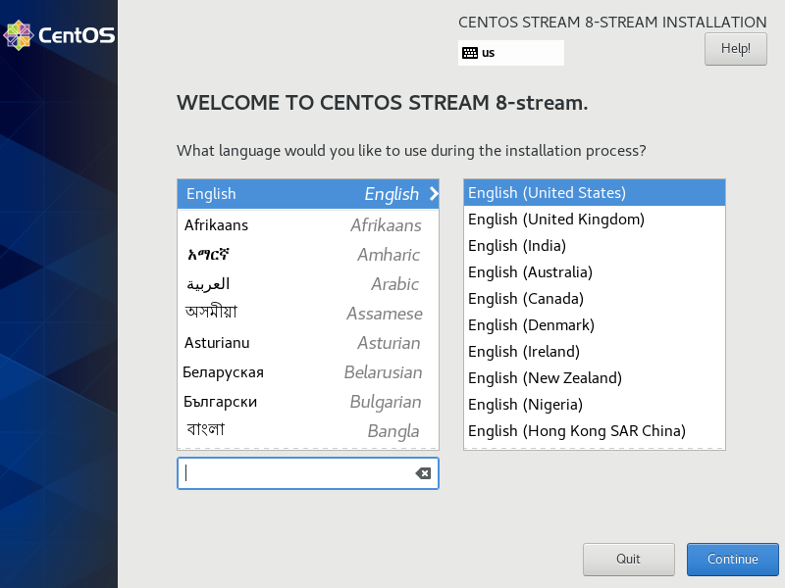

- The main installation window appears, called the Installation Summary window. The items listed with an orange checkmark and reddish font are the only items we must select. Others are optional. For our installation, we will select Software Selection, Installation Destination, Network and Host Name and Root Password. We will select them in this order. So click on Software Selection. After a short pause, the Software Selection window will appear.

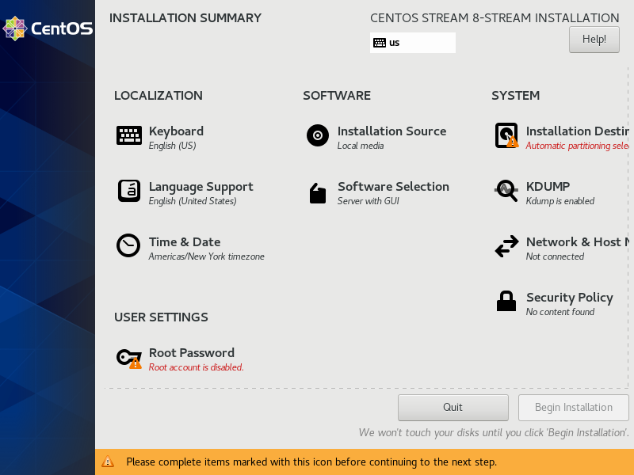
- Under Software Selection, the default type of “Base Environment” is Server with GUI. You can leave this as is although we will assume you select Workstation instead. On the right will be additional software available. Select Gnome Applications. Gnome is the default desktop GUI and this selection installs some of the useful Desktop programs. You may select other software categories if desired but doing so may have a slight impact on later labs. When ready, select Done (in the upper left of the window).

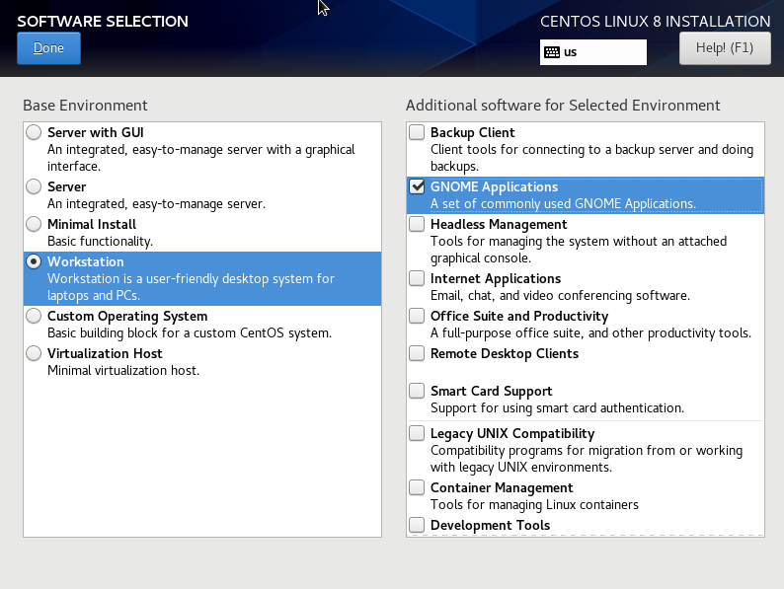

- You are returned to the Installation Summary window. Next, select Installation Destination. From the Installation Destination window (see below), we select the hard disk to use for installation and how we want installation handled in terms of partitioning. There should only be one disk available, called ATA VBOX HARDDISK in the figure below but may be named something else. Click it once to highlight it and then click it a second time which causes a checkmark to appear. If you do not click it twice, it will remain unselected. At this window, we specify how we want the hard disk partitioned. Partitioning choices are Automatic and Custom. Selecting custom allows us to create our own partitioning breakdown or use a Logical Volume Manager. We will do neither and stick with Automatic under Storage Configuration (a later lab will have us create our own partitions). When done, select Done to return to the Installation Summary window.
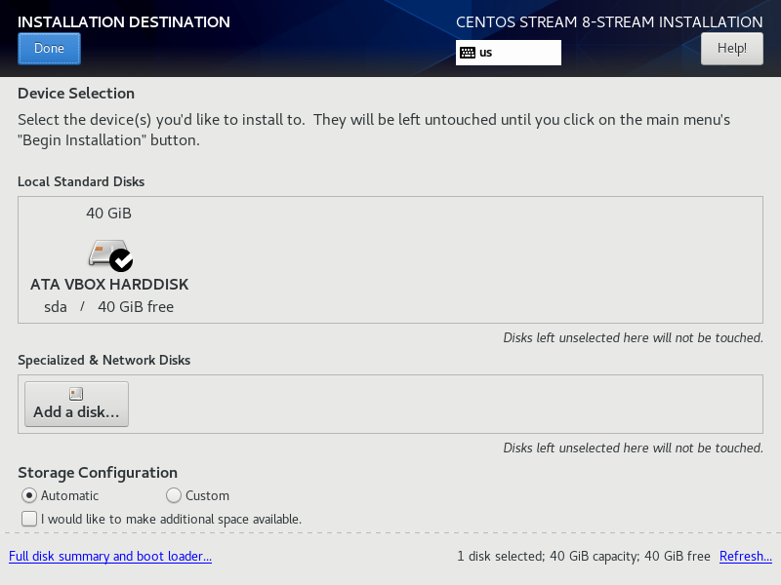

- Next, select Network and Host Name. From here, you will likely see an Ethernet interface device which is not enabled (Off). Change this to On. You can also specify a hostname, set hostname as “OSG203”. Select Done to return the Installation Summary window.
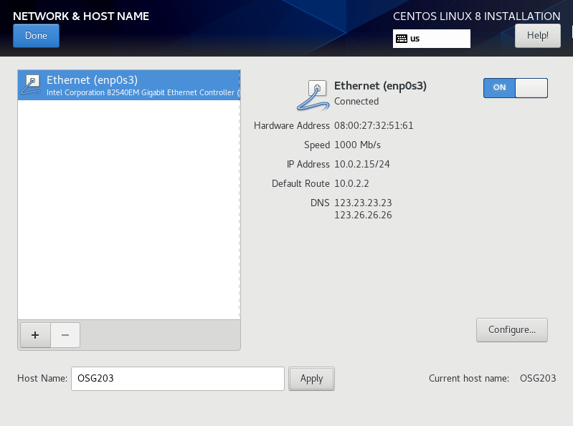

- Select Root Password. This takes us to a window where we will assign a root password. It is critical that you use a password you will remember! As you enter the password, the strength bar will show you how strong the password is. It is assumed that you will use the password LinuxIsCool! but choose any password you like. Enter the password a second time to confirm it and select Done. Upon returning to the Installation Summary window, a new choice appears for User Creation. This choice allows you to create the first user account. Select it and from the Create User window, fill in your full name (for example, "Hoang Van Anh") and then manually edit the username field—although CentOS 8 automatically generates a username (typically in the form of firstinitiallastname), you should replace it with your own by taking your last name and appending the initials of your given name(s) to form a "sort name" (so for " Hoang Van Anh " the sort name is "AnhHV") and then adding your student code (e.g., "HE111111") to create your final username (in this example, "AnhHVHE111111"); also, do not select "Make this user administrator" since we will rely on switching to root when necessary, and be sure to choose a password you will remember (such as "LinuxIsCool!" or another secure option) before clicking Done to return to the Installation Summary.
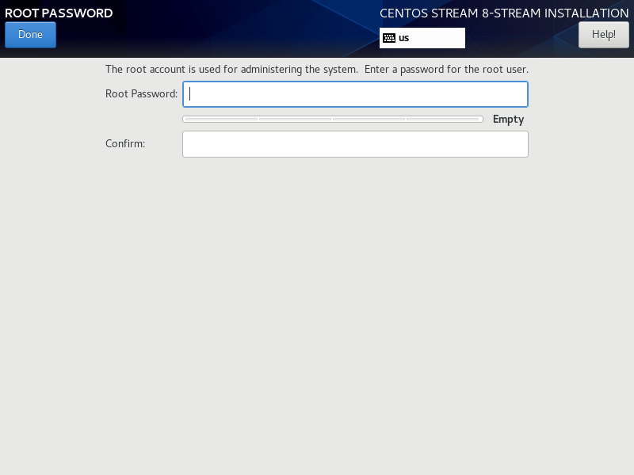

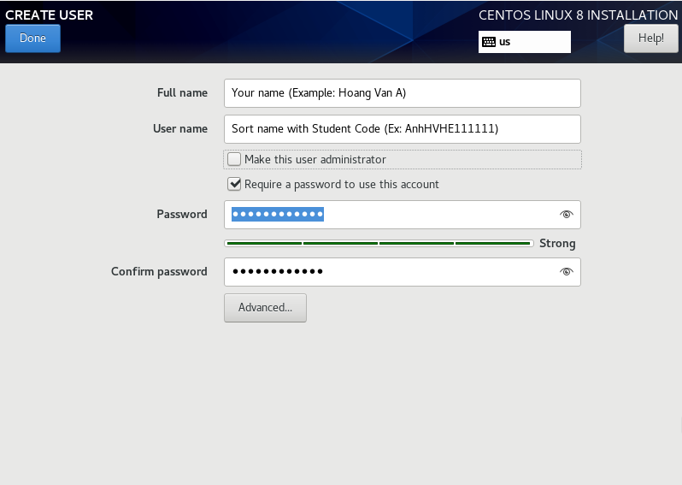

- At this point, the Begin Installation button becomes selectable. Select it (unless you want to make other changes not described here). During installation, a progress bar is provided along with notes on what installation is doing.

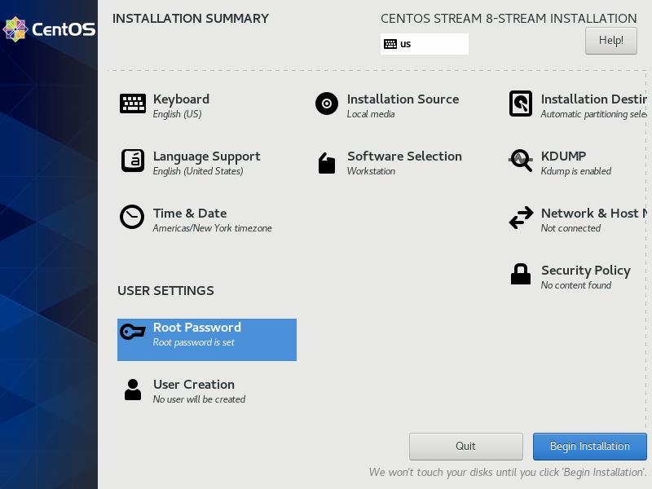

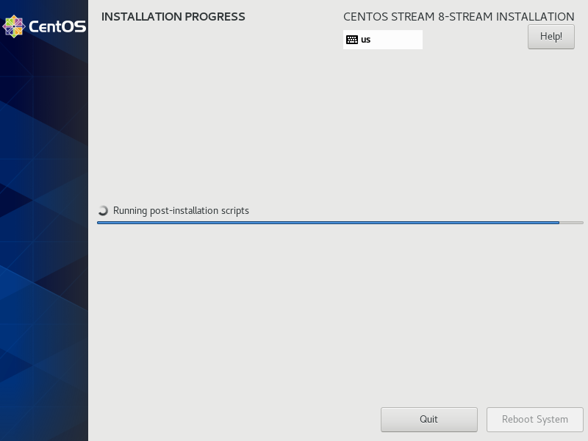

- After installation completes, the button Reboot System is selectable. Select it.

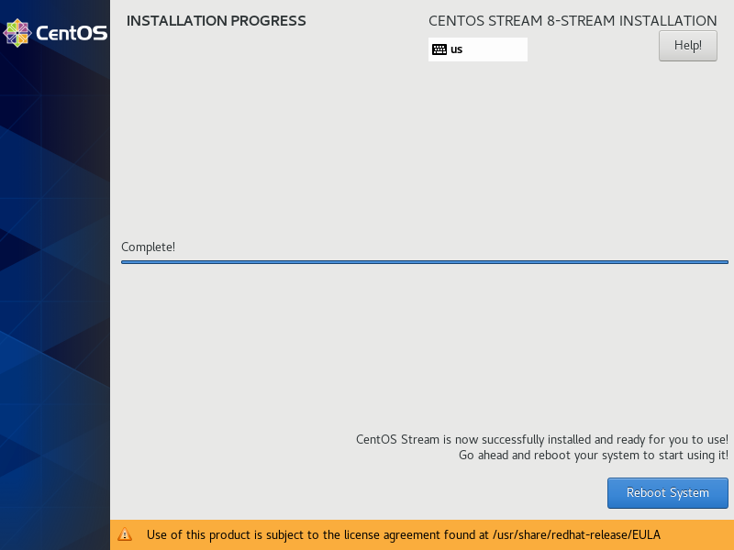

- Finishing the Installation
- Upon rebooting (or booting), we are offered 2 or more options to boot to. We want to boot to the normal kernel (another choice is a rescue kernel). If we do not make a choice, CentOS automatically boots to our normal kernel.
- The first time we use CentOS, we are shown a window similar to the other installation windows, in this case an Initial Setup window. Select License Information, which takes us to the licensing agreement (EULA) for Red Hat 8. Click in the checkbox to accept the agreement and select Done. Upon returning to the Initial Setup window, select FINISH CONFIGURATION.

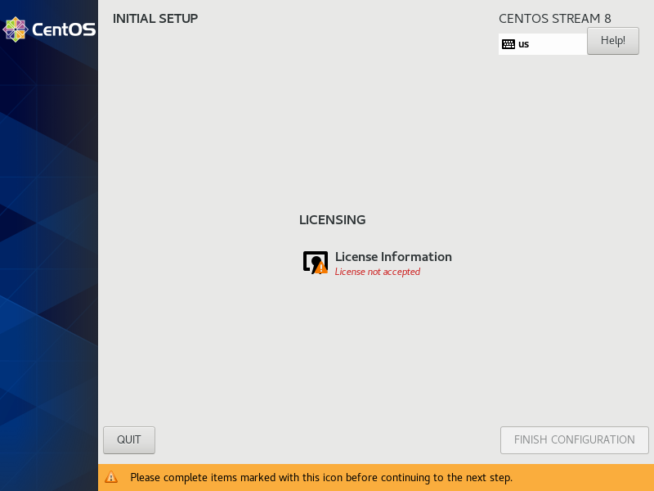

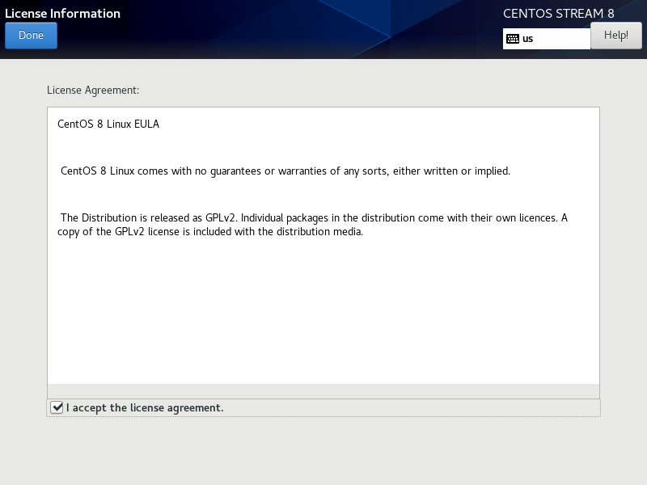

- Using Your VM
- Initial Login
- Having completed the configuration, we are presented the login screen. We will be given this screen every time we boot to our VM in the future. There is only a single account listed, the user account we created. Select it and log in. Notice that Not listed? will give you a box to enter a username and you could log in as root in this way but you should NEVER log in as root through the GUI!

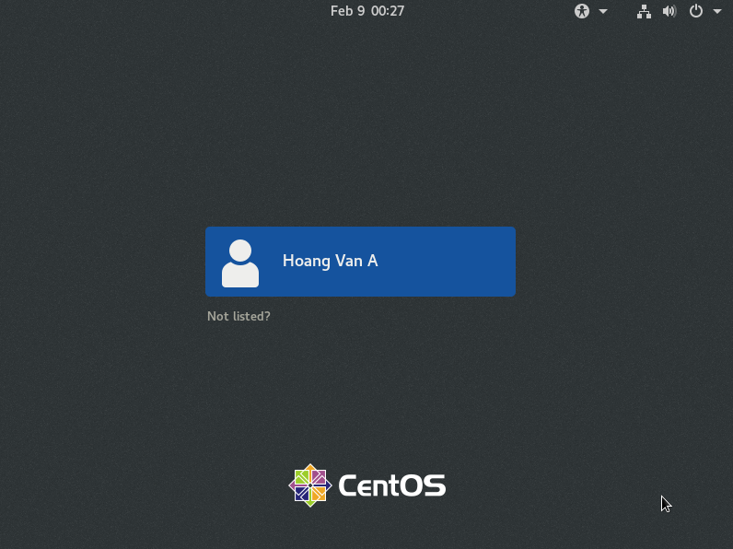

- The first time you log in, you are presented a user setup GUI. From the Welcome page, you can change your default language. Select Next. The next window lets you select a keyboard layout. The default is English US, which defaults to a QWERTY style. Other choices are available. Again, select Next. Next, you can select you privacy setting. The default is to let applications identify your location (ON), you can change this to OFF if preferred. Selection Next. The next window asks you to select any existing accounts from Google, Microsoft, Facebook, etc. By doing so, you are asked to provide your account information. If you want to skip this step, select the Skip button. Finally, you are presented with a Ready to Go screen. Select the button to Start Using CentOS Stream.

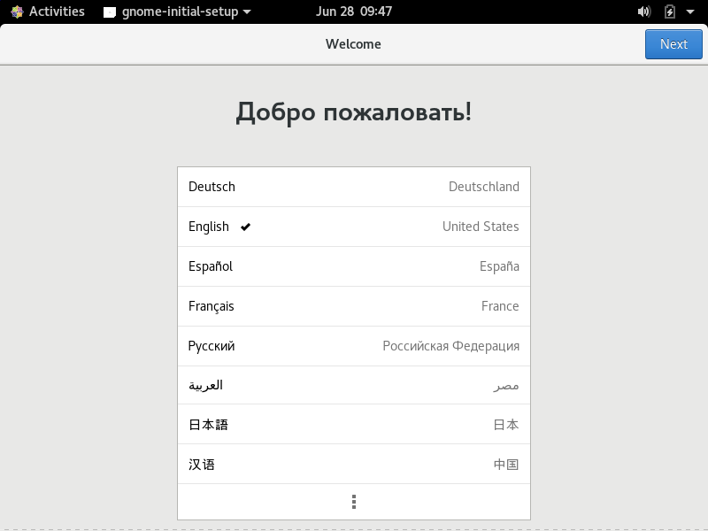

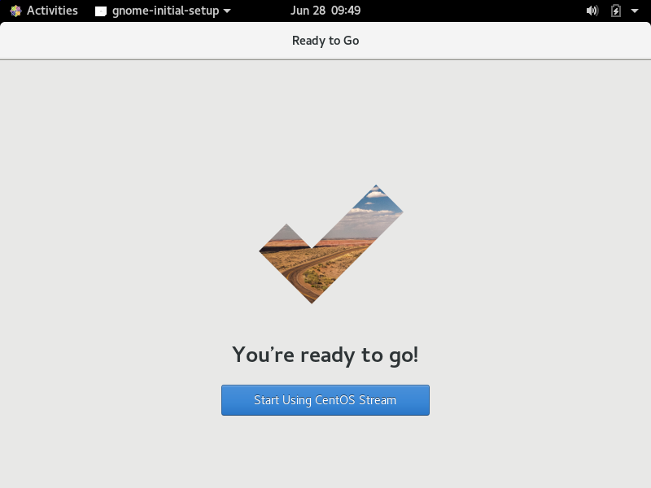

- You are now presented a Getting Started window with GNOME Help. If you want to spend time exploring the help, do so, otherwise close the window (you can close it from the Help menu or clicking on the x in the upper right of the window. You can return to this Help any time you need it.

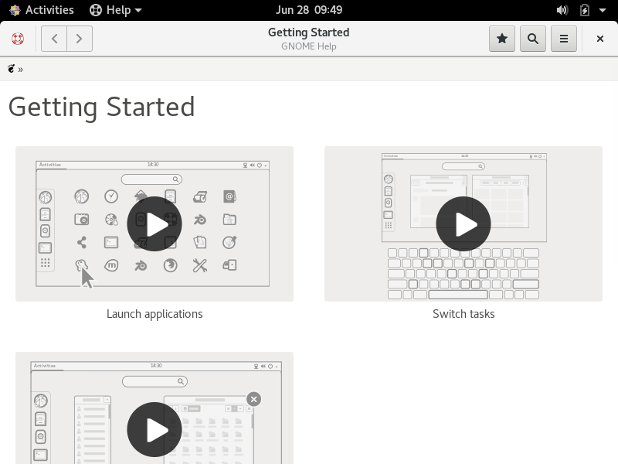

- Using CentOS Stream and Gnome
- The Gnome desktop has changed dramatically over the last two versions of CentOS. The current desktop is similar in CentOS, Fedora and Debian. Ubuntu Linux also has a similar looking desktop. What you will find in CentOS Stream is a single menu called Activities, located in the upper left, and a series of icons along the upper right. Selecting Activities displays a column of icons of favorites.

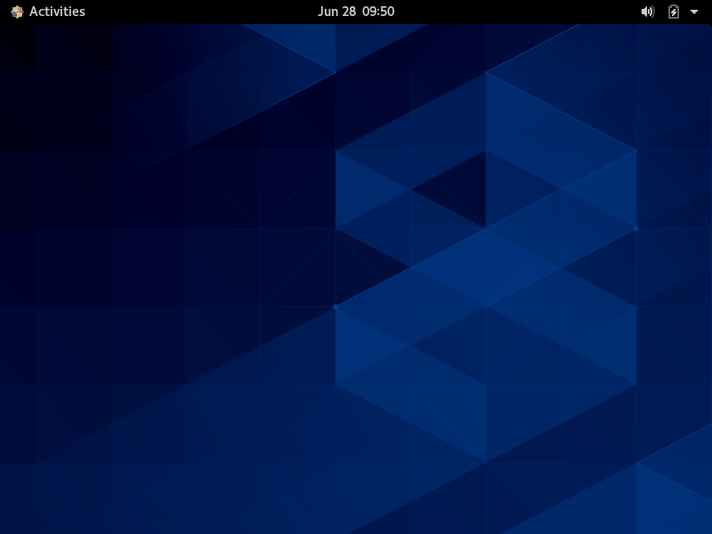
- The default icons are shown below. These are, in order, the Firefox web browser, the Evolution email program, Rhythm Box, the File Browser program, the Red Hat Software program, the Gnome Help program (which you had seen and closed previously) and a terminal window. We will use the terminal window almost exclusively throughout this lab manual. The last choice expands all installed software. Depending on the installation choice and the software selected, as well as the specific version of Linux installed, the software titles will differ. The Workstation installation for CentOS with Gnome Applications added provides only a small list of titles (as shown at the top of the next page).

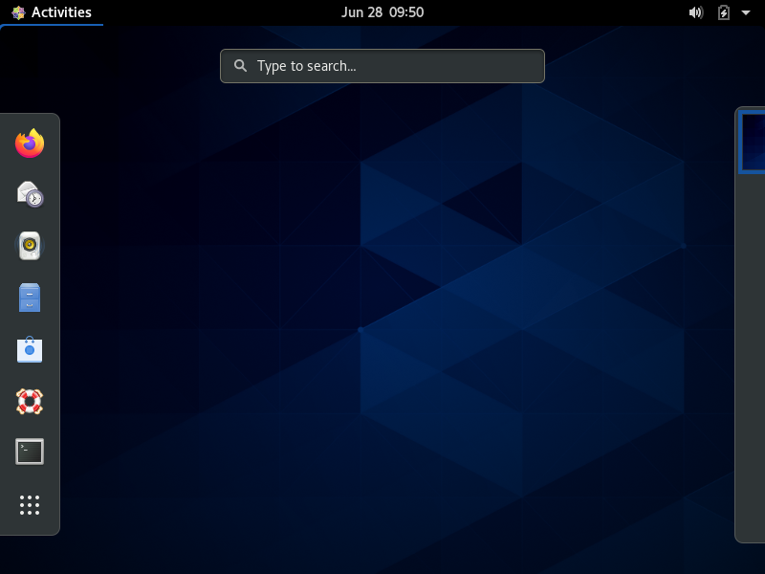
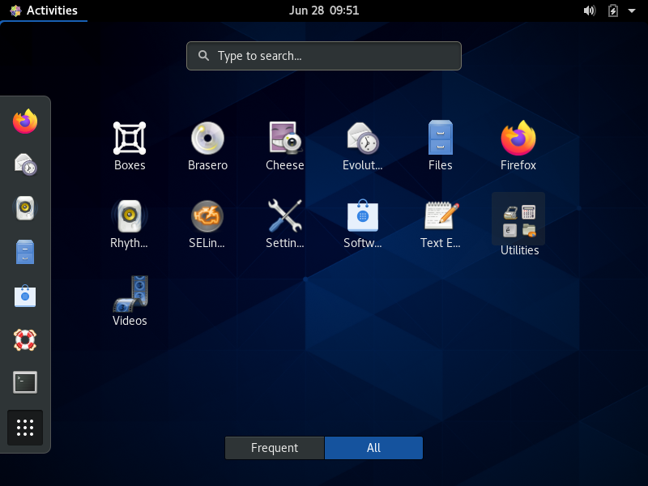

- Notice that all of the Activities icons are also listed here, either directly or under Utilities. Selecting Utilities brings up further titles including the Terminal Window and Gnome Help, found directly under Activities (favorites) as well as a Calculator, System Monitor and a few others). Clicking on Utilities closes the utilities to return us to the software titles. Selecting any software title starts that title and closes the list of software. If we had more software than what is shown above, we will be given some dots on the right side as a “scroll bar” type of mechanism. We can also limit the display by selecting Frequent or use the Search bar. These are not needed in our case because of the limited number of titles. From the list, right clicking on a title brings up a pop-up window that lets us add the title to our favorites to appear under the Activities menu. If the Terminal Window does not appear under the Activities menu, make it a favorite.

- One of the choices under the software titles is Settings. This opens the Settings GUI which is very similar to Settings in Windows 10 except that it has fewer choices. Select it and look through the choices available. If you did not start your Network during installation, you would do so here. To reach the Network selection, you have to scroll down slightly. When done looking at Settings, close the window (click on the x or from the Settings menu, exit). You might notice that when Gnome Help was displayed or Settings were displayed, a second menu had appeared. The Activities menu will always appear. Upon running any GUI application, you are given a menu for that title as well. Usually this menu has very few choices such as quitting or getting help.

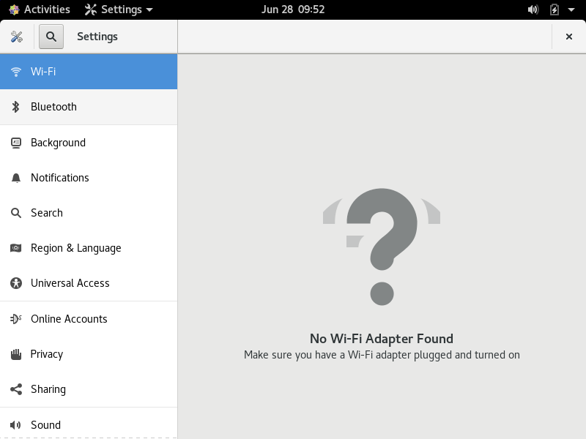

- Another application is the File Browser. Start it and you will be shown the window below. By default, it opens with a view of your home directory, which will be populated with subdirectories similar to what you find in Windows (e.g., Documents, Downloads, Music, etc). There will also be a few “hidden” files (files whose names start with a period, we will explore these in later labs). Spend a little time exploring the files in your home directory and then move to the root directory (/). Linux is set up with about a dozen top-level directories including /etc, /home (where your home directory is located), /usr and others. We explore some of these early in the lab manual but most of them we look at it in detail in the second half. After you have looked around, exit out of the Files tool.

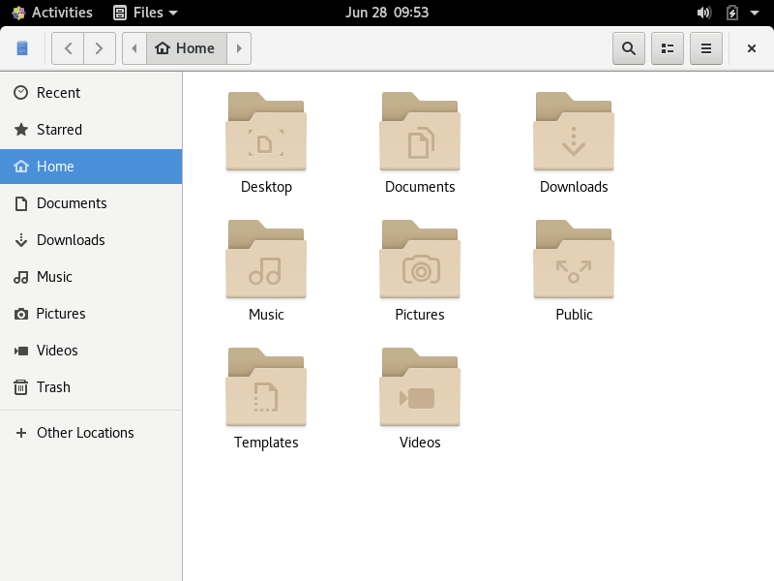

- Next, start the Terminal Window. The new menu, Terminal, has a very useful option to open a new window. From here, we can open several terminal windows. You will find this might be useful in later labs. For now, the one window is more than sufficient. Starting in the next lab, you will explore command line entry and features found in Bash to help you. For now, you will type in just a few commands.
  - Start with pwd. This will show you your current working directory.
  - Next, type whoami and it will display your username. You can find both of these pieces of information in your prompt (~ is shorthand notation for your home directory).
  - Type date to get the time and date.
  - Type ls to list the contents of your home directory. Next, type ls -a to show hidden files. Finally, type ls -al to show a long listing of the contents.
  - Optional: if you want to change your password from LinuxIsCool! to something else, then type passwd. When prompted, enter LinuxIsCool! and then enter your new password and confirm it. If you forget your new password, you can log in as root and change the password. Instructions for this are given in lab 12.

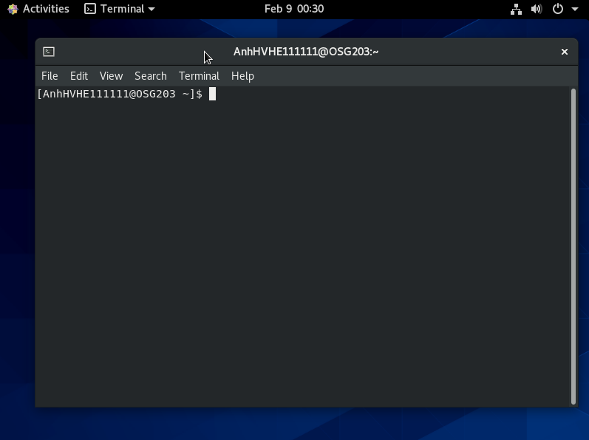

- We have one last task to accomplish. Throughout the first half of this manual, you will use an already-populated system with other accounts, directories and files. The content will be downloaded and installed for you using a script. First, you need to be root for this. Type su <enter> and enter the root password (LinuxIsCool!). The su instruction allows you to switch user. With no username specified, we are asking to switch to root. Once logged in as root, you will notice the prompt changes. Now, type the command wget www.nku.edu/~foxr/linux/setup.sh. If this command does not work, use sappho.nku.edu or this link. Next, type the command chmod 755 setup.sh. This makes the script executable. Finally, run the script by typing ./setup.sh. The script will take a few moments to execute. It creates three new accounts named foxr, zappaf and Student, downloads files from the same location using wget, and then untars (unzips) the files and moves the contents into those user accounts. It also updates their passwords all be LinuxIsCool! You can su into any of the three accounts and will do so later in the labs. Leave root by typing exit. This returns you to your account.
- You may now close the Terminal Window (from the Terminal menu or closing the window with the x, you can also exit by typing exit). To shut down the VM, you can do so from VB or from within Linux. We will use this latter approach. In the upper right hand corner of the desktop are three icons, a speaker to adjust volume, a battery symbol showing your computer’s charge, and a down arrow. Clicking on any of them opens a pop-up window with choices to adjust the volume, alter your network connectivity, change user, bring up settings, lock the screen, or shut down. Clicking on the power button brings up a further list of choices to reboot, log out or shut down. Select shut down. This will not only shut down both the Linux OS and the VM and return you to the initial VB interface, which you can exit out of.

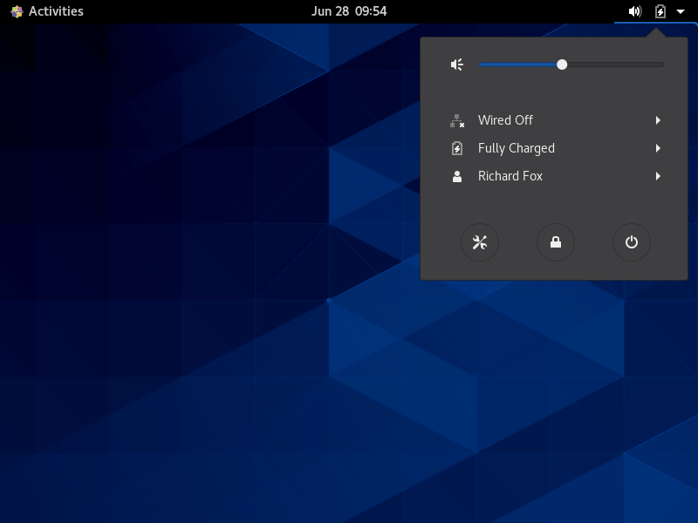

NOTE: this lab has no questions for you to answer. All remaining labs will have questions as part of the assignment.

Close your terminal window and shut down your VM.

